**Thomas Martin**

**CS-340-11221-M01 Client/Server Development 2024**

**2-1 Assignment: CRUD in MongoDB**

**Southern New Hampshire University**

**May 08, 2024**

Screenshot of the terminal window “id :”10021-2015-ENFO”

Screenshot of the terminal window "result":"Out of Business"},{"business_name":1}).limit(10)

Screenshot capturing the terminal window commands executed within the MongoDB shell. These commands are responsible for inserting a document into the 'inspections' collection within the 'city' database. Notably, the inserted document features a subsection for the address and employs the new Date() function to accurately capture today's date. The successful insertion has been subsequently confirmed using the findOne() function with the specified ObjectId 663bfe35324a0d2ff7c74af4.

Screenshot of the distinct list of inspection “sector” in the current inspections collection.

Screenshot of the inspection sector list from the current inspections collection. Utilizing the "length" function, it is confirmed that there are 87 records found. This eliminates the need for manual counting, ensuring accuracy and efficiency in the process.

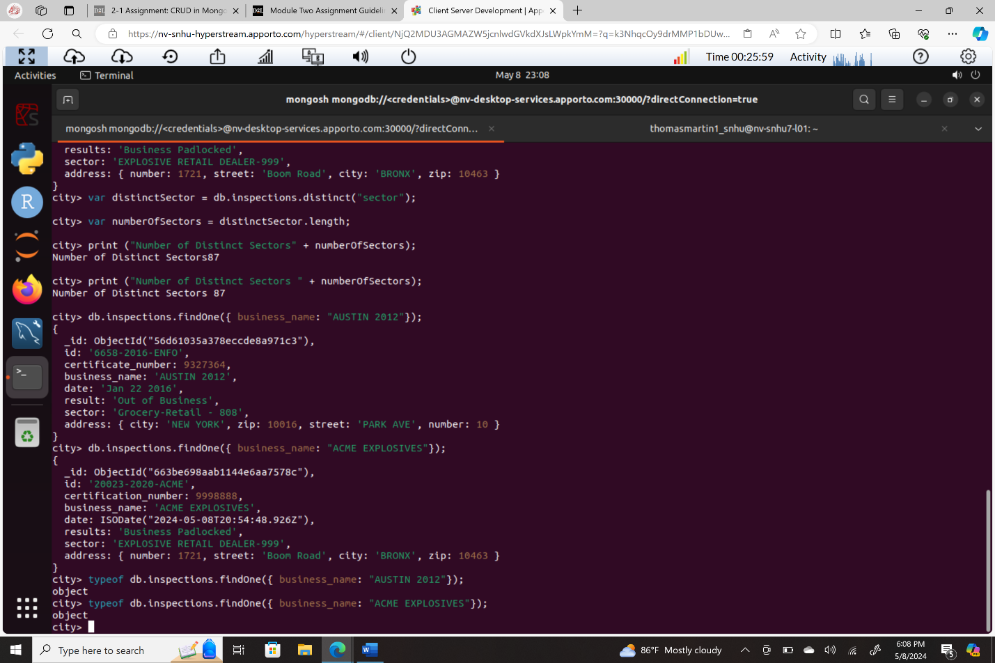

The difference in the date data type between the business named "AUSTIN 2012" and the insertion of "ACME EXPLOSIVES" lies in how the dates are represented. Date for "AUSTIN 2012" is represented as a string (Date: Jan 22 2016) while the date for "ACME EXPLOSIVES" is represented as an ISODate object (Date: ISODate("2024-05-08T20:54:48.926Z"). Using the “typeof function shows both records to be object type.

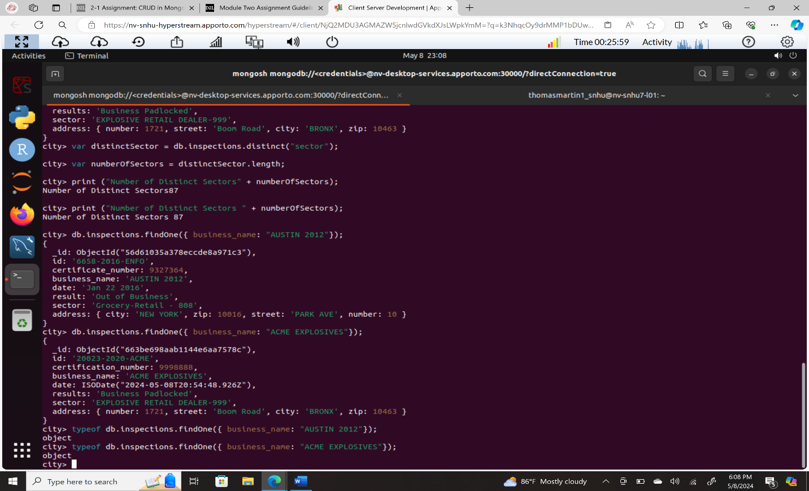

Screenshot of number of businesses that have a “Violation Issued” citation.

Screenshot of command in the mongo shell, “updateOne” with the ID “20032-2020-ACME” in the collection “inspections” in the database “city”.

Screenshot contains the key-value pair "city":"ROSEDALE" in the address subdocument by changing the zip code in the address subdocument to "76114".

Screenshot of first document with the key-value pair "result":"Violation Issued."

